* Task 1: Provision the lab environment

Instaling the Network watcher extension

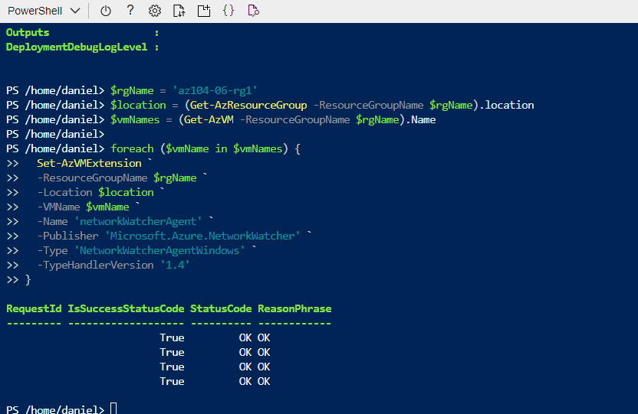

* Task 2: Configure the hub and spoke network topology

Added peerings

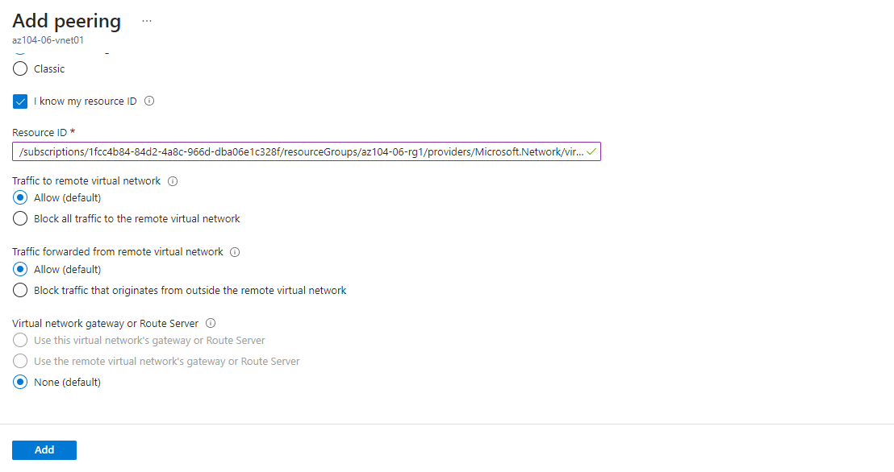

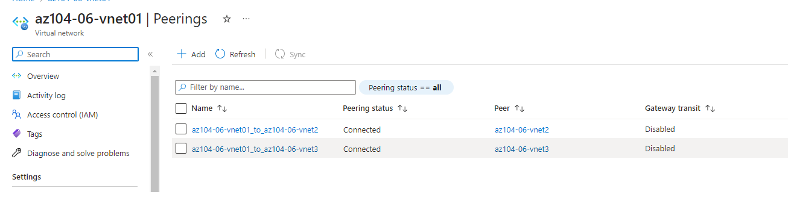

* Task 3: Test transitivity of virtual network peering

Checking connectivity of vms

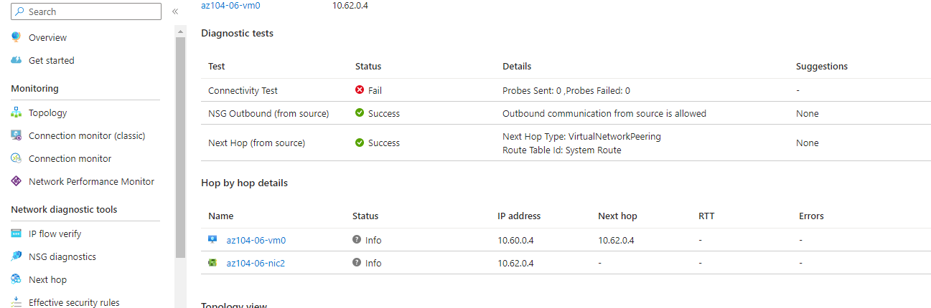

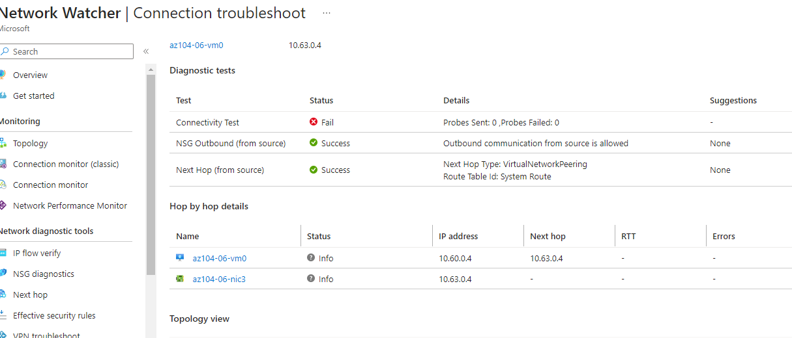

* Task 4: Configure routing in the hub and spoke topology

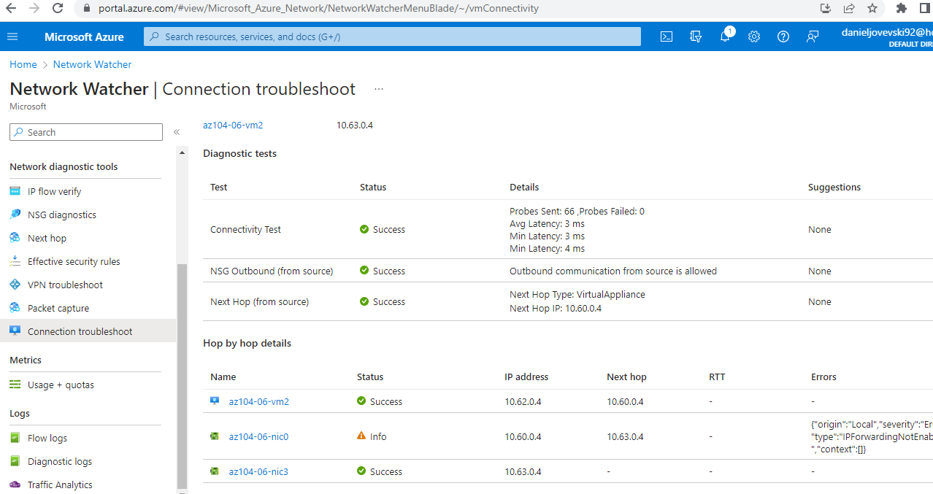

* Task 5: Implement Azure Load Balancer

Navigation to public IP and checking that Load Balancer works

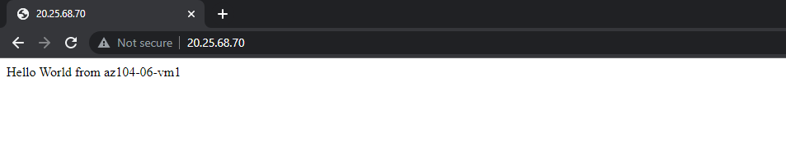

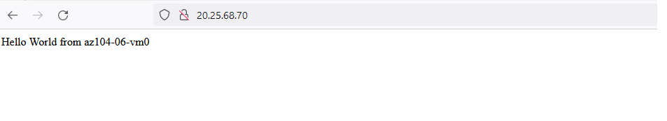

* Task 6: Implement Azure Application Gateway

Navigation to the public IP and checking the balancer works

